Logo%20Main%20200

**Boston University**

**Electrical & Computer Engineering**

**EC463 Capstone Senior Design Project**

**Problem Definition and Requirements Review**

NoiseHub

Submitted to

Michael Hirsch

8 St. Mary’s St

(617) 353-2811

mhirsch@bu.edu

by

Team 8

Team NoiseHub

Team Members

Allen Zou [allenzou@bu.edu](mailto:allenzou@bu.edu)

Benjamin Brewer [bbrewer1@bu.edu](mailto:bbrewer1@bu.edu)

Ibrahim Chand [ichand@bu.edu](mailto:ichand@bu.edu)

Alexander Prior [aprior@bu.edu](mailto:aprior@bu.edu)

Submitted: 10/22/2021

**Customer Sign-Off _______________________________________**

#### NoiseHub

#### Table of Contents

Project Summary 2

1 Need for this Project 3

2 Problem Statement and Deliverables 4

3 Visualization 5

4 Competing Technologies 6

5 Engineering Requirements 7

6 Appendix A References. 8

# Project Summary

College study spaces are often inconsistently managed. That variability can hinder a student’s productivity, especially when they spend time finding a comfortable location rather than studying. NoiseHub aims to give students the ability to find the perfect study space by providing accurate temperature, headcount, and noise information about locations. This is done using a small embedded system consisting of Raspberry Pi’s and sensors that can be mounted easily in any room. With our backend hosted on AWS, data is compiled into a user friendly format on the NoiseHub companion app.

# Need for this Project

NoiseHub aims to eliminate the common frustrations associated with trying to work in a public study space. Many students, researchers, faculty, and staff often arrive at a public space only to find it too hot, crowded, or loud to work comfortably. A comfortable work environment helps increase productivity and NoiseHub aims to do just that. By taking a few seconds to check the NoiseHub app, our users can focus on getting work done productively rather than wasting time searching for a space that fits their unique needs.

NoiseHub aims to partner with select universities to provide this service to its students, researchers, faculty, and staff. Universities should aim to provide comfortable work spaces to increase productivity and reduce burnout, making them the perfect use case for NoiseHub. By partnering with us, universities are actively investing in a more productive and comfortable campus experience for their students and employees.

Long term, this project can also be expanded for use in general businesses. In the same way that rush hour traffic data can help decongest the road by suggesting alternative routes, stores can advise customers on their busyness before they arrive. For example, if a user notices that their local coffee shop is currently experiencing high volume, but is predicted to be empty in an hour, they can make a more educated decision on when to go. This benefits both the consumer of our product as well as their customers since it can help normalize the flow of customers through their business as well as help decrease average wait times.

# Problem Statement and Deliverables

The goal of this project is to deliver a fully integrated and easy to implement system. This can be divided into looking at what the consumer (purchasing organization) receives, as well as their clients (students, patrons, etc.).

Upon purchase of this product, the consumer will be able to quickly set up the integrated hardware, and the NoiseHub team will work with partners to customize the companion app for their unique spaces. The consumers' clients will receive access to live data and predictions through said app, with which they can make fully informed decisions on where to go to best meet their needs. This achievement will be met through the deliverables, which can be broken down into the hardware and software components.

The hardware will contain a wall powered Raspberry Pi with a thermistor, microphone, and thermal camera or ultrasonic sensors to gather temperature, noise level, and headcount approximations as stated in the Project Summary. The Pi will send data to the backend for processing and storage. The Pi, temperature, and noise sensors will be housed in a manufactured shell which can be easily wall or ceiling mounted, while the headcount sensors will be mounted on the doorframe. The consumer will determine how many units they wish to purchase, and the recommended square footage per unit will be determined during development.

The software contains two parts: backend and frontend. The backend will include five parts. First, DynamoDB to store user data and sensor data over time to observe trends and make accurate predictions. Second, Cognito to authenticate users and make the sign in process simple. Third, Lambda, which will use the stored data to make predictions on room conditions of upcoming times and days. Fourth, AppSync which acts to manage all the software components working together. Fifth, Amplify to communicate between components and connect the backend to the frontend.

The frontend will consist of a cross platform app with an intuitive UI/UX flow. The frontend code will use generic names for items that can be personalized by different consumers. Examples of this would be a school logo, or the university mascot. Items such as this will be stored in setup files, which the consumer can set up themselves to their preference. When using the app, the consumers' clients can search for study spaces and filter based on personal preferences. An example would be one student who thinks room temperature is most important while studying, versus a second student who believes noise level is key. Study space proximity in relation to the user will also be a factor.

# Visualization

The hardware behind NoiseHub will consist of a Raspberry Pi 4 Model B, decibel noise sensor, thermistor, and either a thermal sensor IR array or two ultrasonic sensors for headcount. The Raspberry Pi will be continuously powered via a USB C wall brick, and the sensors will connect to the Pi via GPIO pins. The Pi will require an internet connection, wired or wireless, in order to communicate with NoiseHub’s AWS services.

The sensor data will be streamed in real time to AWS RDS. The data will be processed on AWS Lambda in order to draw meaningful conclusions about peak and low noise, temperature, and headcount data. The companion mobile app will then query the latest data from RDS to display in an easy-to-read UI. The app will plot sensor data over time and provide quick access to processed information like future busyness levels.

The companion app will have a strong focus on UI/UX. The core of NoiseHub’s mission statement is to save its users’ valuable time when trying to find a study or work location. The more intuitive the application is, the faster users will be able to get work done. As a result, the UI/UX will be designed to provide a streamlined experience. The home screen will feature overviews of the user’s preferred study spaces to provide the most relevant information at a glance. If additional information is needed, the user can simply click on each space’s overview for an in-depth look with graphs to analyze the data and other relevant information. In terms of graphical representations of the data, the user will have the ability to choose a range of time and the types of data to visualize.

. 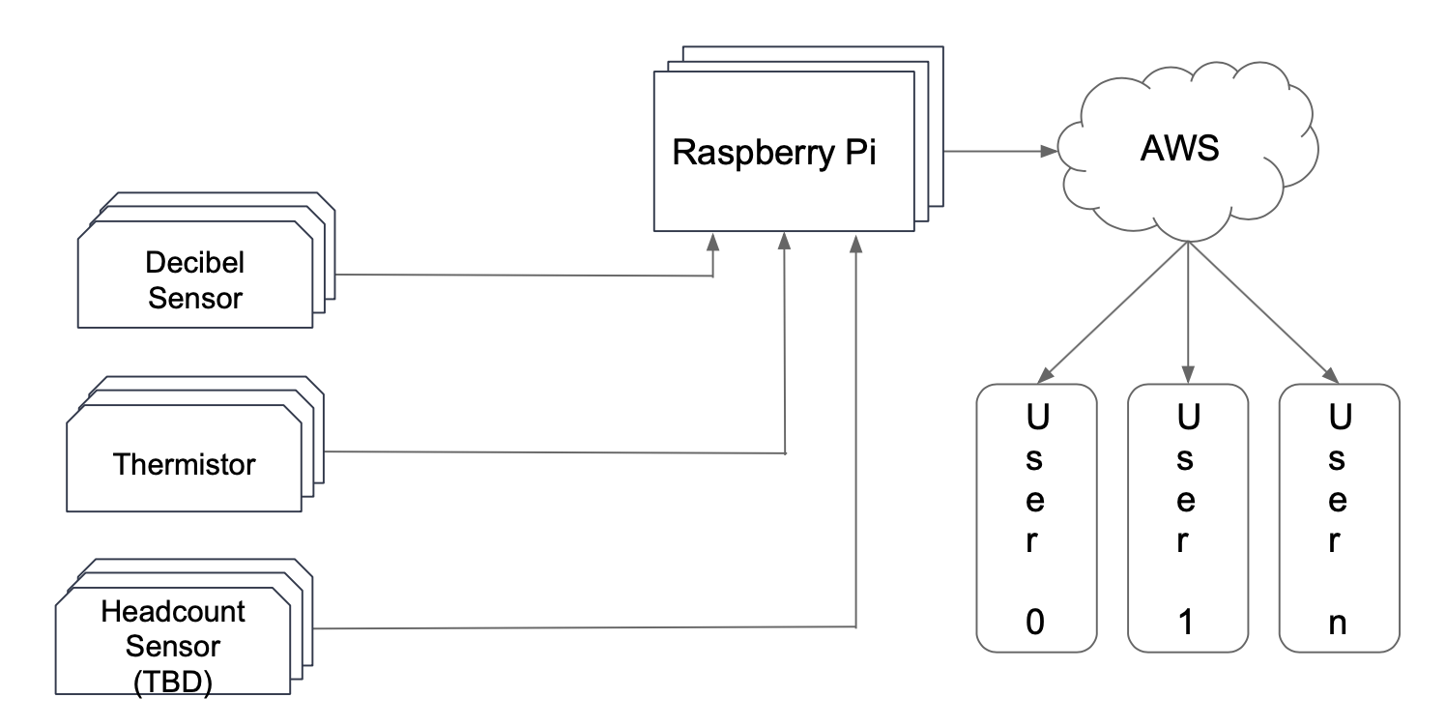

*Figure 1.1*

*This flowchart details the connections between the sensors, Raspberry Pi, AWS services, and users.*

# Competing Technologies

The leading competing technologies are similar to each other, they have the same goal of reporting crowdedness and volume of given areas, but achieve this through user input. One of these products is Soundprint, which asks users to measure decibel levels with their phones when at a restaurant, bar, etc. This decibel level is uploaded and posted to the apps page for that location, functioning similarly to Yelp.

Another example would be iHearU. This is almost identical to SoundPrint, asking users to gather data for the company and reporting it on the app. However, iHearU is sponsored by the American Hearing Loss Association, giving them an advantage in funding.

The third and final example is Hush City. Like SoundPrint and iHearU, users are required to provide data and input for the app to evaluate and report on locations. Hush City’s niche is that they focus towards outdoor areas such as parks, and users are also required to upload a photo and environmental conditions such as air quality.

The main takeaway from these competing solutions is that they leverage user input to their advantage, while our solution makes using the app as easy as possible by using electronic sensors. This could be useful to wrap in with our design, asking users for feedback on how accurate our readings are. This would be helpful in cases where our headcount has gone askew and help correct it. Furthermore, if one location's readings are consistently getting conflicting feedback from users, it will be easier for our team to isolate which units require maintenance.

# Engineering Requirements

**5.1 Mechanical**

1. The device casing must be smaller than 7” L, 5” W, 4” H including the Pi, decibel, and temperature sensors.
2. The thermal sensor IR array or ultrasonic sensors will need to be cable managed around a door frame nearby the Pi.
3. The device must be quieter than ambient room decibel readings to prevent interference with the audio sensors - around 30 decibels.

**5.2 Data Analysis**

1. Data models will be leveraged via AWS Lambda to predict when peak and minimum noise levels occur.
2. Daily noise, temperature, and headcount data will be accurately graphed over a 24 hour period.

**5.3 Maintenance**

1. The device will require little to no maintenance, drawing direct power from a wall outlet and is able to be managed remotely over SSH.
2. Data is not stored locally on the device so it is not constrained by storage.

**5.4 Accuracy & Cost**

1. Headcount accuracy will be greater than 50%.
2. Temperature accuracy will be within 10 degrees Celsius.
3. The total component cost will not exceed $500.

# Appendix A References.

Cokbas, Mertcan, et al. “Low-Resolution Overhead Thermal Tripwire for Occupancy Estimation.” *2020 IEEE/CVF Conference on Computer Vision and Pattern Recognition Workshops (CVPRW)*, 2020, <https://doi.org/10.1109/cvprw50498.2020.00052>.

Belluz, Julia. “Restaurants Are Too Freaking Loud. This App Helps You Shame Them.” *Vox*, Vox, 26 Apr. 2018, <https://www.vox.com/science-and-health/2018/4/26/17275406/restaurant-noise-app>.

Hush city app. (n.d.). Antonella Radicchi | Architect and Urbanist, PhD. April, 2017 <https://www.antonellaradicchi.it/portfolio/hush-city-app/>.

Coquillat, Diego. “IHEARu, the App That Detects Noisy Restaurants through Crowdsourcing.” *Innovation, Marketing and Technology Restaurants | DiegoCoquillat.com*, 6 Mar. 2018, <https://www.diegocoquillat.com/en/ihearu-la-app-que-detecta-los-restaurantes-ruidosos-a-traves-del-crowdsourcing/#:~:text=It%20is%20they%20who%20when,the%20visibility%20property%20one%20iHEARu>.